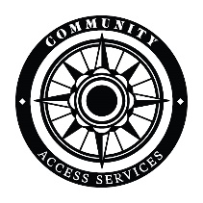

Community Access Services
3297 Bailey Avenue
Buffalo, New York 14215
We offer a three-day supply of food through our food pantry for qualifying community members in the 14215 zip code.
In order to participate, please provide the following:
- Identification for everyone in your household
- Proof of residency
- Proof of income
Have questions? Please call us at 716-852-5969
The Pantry is open every Wednesday from 9:30 a.m. - 4:30 p.m.

